* **Lists**
  + Lists are very similar to arrays
  + They can contain any type of variable, and they can contain as many variables as you wish
  + Lists can also be iterated over in a very simple manner
  + Lists can contain duplicate items
  + Examples

fruit = ["apple", "banana", "cherry]

**myList = []** aka “the empty list”

* **Accessing Items in a List**

print(**fruit[1]**) prints out “banana” # 2ND VALUE

print(fruit**[-1]**) prints out “cherry” # LAST VALUE

print(fruit**[0:2]**) prints out Indexes 0 & 1, stops at 2nd index

* Add an item to the end of the list, USE the **append()** method:

fruit**.append("orange”)**

* To add an item at the specified index, use the **insert()** method:

fruit**.insert(1, ”grapes”)**

**To remove items from a list -** fruit= ["apple", "banana", "cherry”]

* + The **remove()** method removes the specified item:

fruit**.remove("banana")**

* + The **pop()** method removes the specified index, (or last item if not specified):

fruit**.pop()**

* + The **del** keyword removes the specified index:

**del** fruit[0]

* + The **clear()** method empties the list:

fruit**.clear()**

**Loop through List:**

**for x in fruit:**

**print(x)**

* **To copy of a list:** 
  + Method **copy() ->** newfruit = fruit**.copy()**
  + Another way to make a copy is to use the built-in method **list()**

newfruit **= list(fruit)**

* + Using the **list() constructor** to make a new list

newfruit= **list(("apple", "banana", "cherry"))** # note the double round-brackets

**to join, or concatenate, two or more lists:**

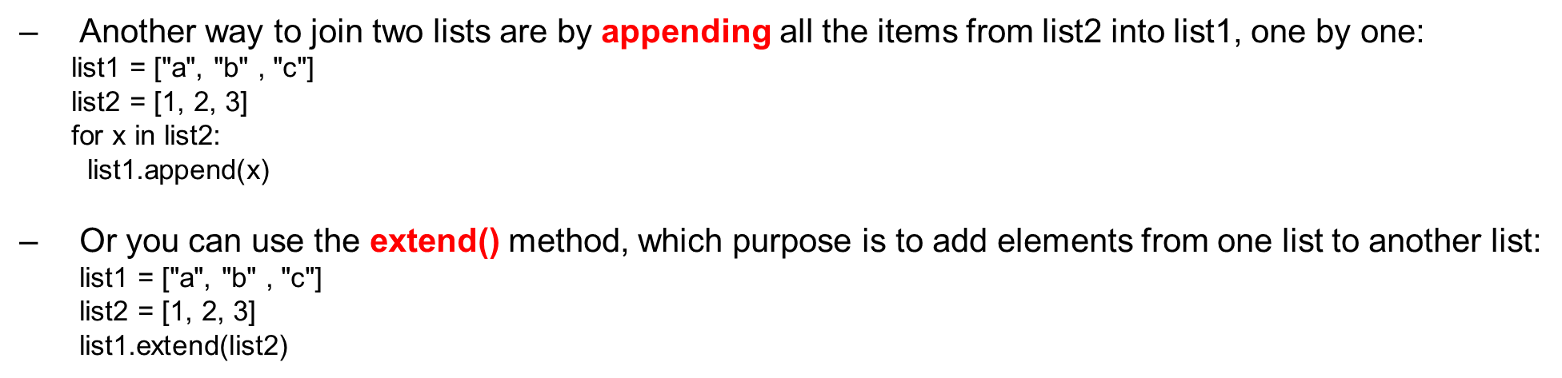list3 = list1 + list2

* To return the number of times a value appears in a list, use the **count()** method

fruit = ['apple', 'banana', 'cherry']

x = fruit.count("cherry") returns the number 1

* The **index()** method returns the position at the first occurrence of the specified value

fruits = ['apple', 'banana', 'cherry']

x = fruits.index("cherry") returns the number 2

* The **reverse()** method reverses the sorting order of the elements

fruit = ['apple', 'banana', 'cherry']

fruit.reverse()

* The **sort()** method sorts the list ascending by default smallest to largest or alphabetically or specifying which order as an optional input

fruit = ['apple', 'banana', 'cherry']

fruit.sort(reverse=true)